Introduction:
Date of Submission: September 26, 2013
The domain “Banking System” keeps the day by day tally record as a complete
banking. It can keep the information of account type, account opening form, deposit,
withdrawal, and searching the transaction, transaction report, individual account
opening form, group account. The exciting part of this project is; it will display transaction
reports, statistical summary of account type and interest information.
Description:
a) System Design:
In real world application for bank management, many types of system designs are followed. There could be different application for client, admin, and employee. There may have web application in addition to desktop application. All that design depends on system designer and bank authority. For simplicity, in this project there will be one application with different user interface. The whole process is described below-
- Log in: The application will require log in mandatorily. Now, before log in, the user have to define whether he is admin, client or employee. The wrong information will give error report with appropriate suggestions.
- User Interface (UI): Depending on the type of user, there will have different user interface with different functionality.
- Access Control: This is the most important layer of the system architecture. The access control is different for different user. Admin has permission to make all kind of change in database, where employee has the permission to access his personal information only. Again, client has permission to access his information and transactions only. Whenever, a valid username and password will be given for specific user, the application will allow him/her to access the specific information of the bank database. Again, the modifying option will not be permeable for all users. Some user may have read only permission, where some user may have read and write both permission. An error report will be given if any user wants to check the forbidden data for him. Thus the security control will be provided.
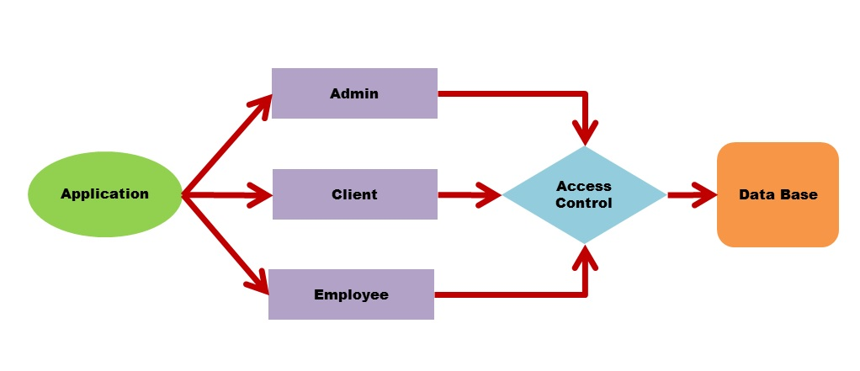
Figure 1: Bank Management System Architecture.
- Database: All the information of the banking system will be preserved in database tables. The relationship between the entities will provide appropriate information to the user.
b) Basic Ideas of Banking System:
- General information: The system requires general information of the user to open an account. The important fields of information are – Short Name, First Name, Middle Name, Last Name, Present and Permanent Address (Holding No., Street, Village, Sub-district, District, Division, Country, Postal/Zip Code, Phone/Mobile no. of residence, office ), Birth Date, sex, marital status, Race, Profession, Business type(for corporate customers), Nationality, National ID, Passport No., TIN, Spouse Name, Father’s Name, Mother’s Name, Photograph, Account No., Customer ID etc.
- Account Types: In general, there are four types of account are provided to the customers -
- Current Account. 2) Savings Account (Pension Savings, Monthly Savings).
- Time Deposit/ Fixed Deposit Account. 4) Short Term Deposit Account.
- Loan Types: There are many kinds of loan are provided to the customers depending on the category of the bank. General loans given by the commercial banks are -
- Business loan (OD). 2) Time Loan. 3) Consumer Loan.
There could have Retail Loan (Personal Loan, Car Loan, Home Loan, Education Loan), Agriculture Loan etc.
- Interest: There exists interest rate on every type of deposit and loan. Customer gets interest for depositing and gives interest for taking loans. The interest rate is a variable quantity. It changes along with time. Again, Business Loan and Time Loan requires mortgage of property. Customer will get loan of a certain percentage of the total value of the property. If customer is unable to repay the loan in time, the mortgage is sold out by the bank.
- Transaction:
Transactions are done in many ways. It could be done by cheque, Credit/Davit Card, Online Transfer, Telegraphic Transfer etc. All the customers of the bank get a davit card with the opening of an account. However, Credit Cards and International Cards are given across a certain amount of deposit money.
Functionalities:
- Module Description: The main module of the system is described below –
Module | Description
Create File | Selecting this, creates a new file for the user by accepting input such as, account number, name and account etc.
Open Account | Opens a new account for the user by accepting input such as account number, name and minimum balance.
Search | Enables to search for the details of the given account number. Displays only one account detail at a time.
Deposit | Provides option to deposit amount to the given account number.
Withdraw | Provides option to withdraw amount from the given account number.
Cancel Account | Cancels the selected account from the bank.
Report | Displays the list of all account details comprising of the account number, name and balance account.

- Model of the Modules:

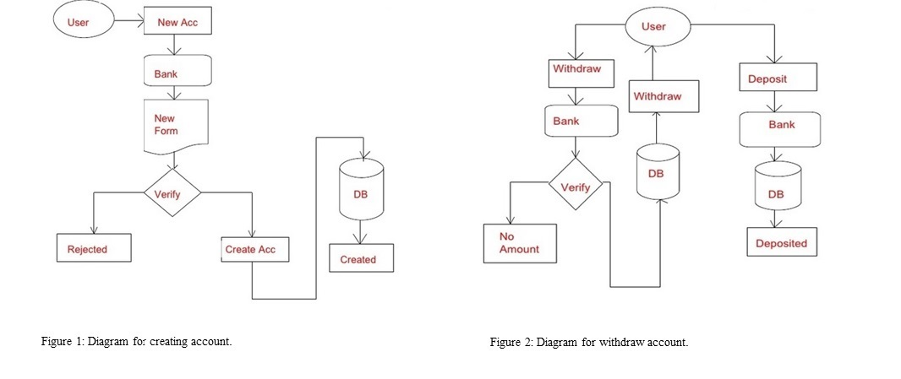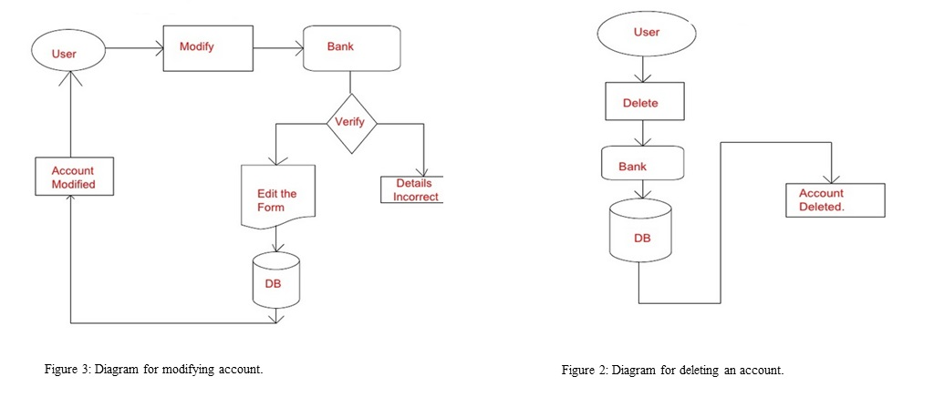
Tool Chain:
For developing this project, the following tools will be used –
- C# Language.
- SQL / MySQL Query Language.
- SQL Management Studio.
Conclusion:
Though it is tough to get the attributes of a bank management system database from the banks for security issue, the project will use general outline of banking system. But, there will be kept option to modify anything needed. There is a future plan to expand its scope to the online application.
References:
- Bangladesh Bank – Credit Information Bureau.
- South East Bank Limited, Haji Hanif Complex (1st floor), 12 & 13, Khan Jahan Ali Road, Khulna.
- United Commercial Bank Limited, Khan Jahan Ali Road Branch, Khulna
- Dutch Bangla Bank Limited Useful Forms - http://www.dutchbanglabank.com/electronic_banking/forms.html
- Bank Management System –
http://www.slideshare.net/vivekk1989/bank-management-system-1852764
- JAVA J2EE Tutorial – Enterprise Beans –
http://ulm.uni.udm.ru/~oam/j2ee/tutorial/1_3-fcs/doc/Ebank2.html
- BankSystemVedio.mp4
http://www.youtube.com/watch?v=oDKvwBWBIbc

